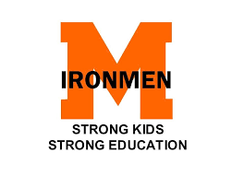

May 6, 2020

In an effort to be consistent with the Emergency Order from the Health Department of Northwest Michigan, Mancelona Public Schools will be screening all staff reporting to work. Please click on the link below to complete a form EACH TIME you are working on site until otherwise notified. This includes meal prep and delivery. If you answer yes to any of the questions, please notify your supervisor and please do not enter the building or school buses until notified. Thank you for your cooperation and all that you are continuing to do for our students.

https://forms.gle/rJ3cT4U5q4fYCGP59
Thank You,
Mancelona Public Schools

